A Project Report on
OceanGuard
A Real-Time Marine Pollution Reporting & Response Platform
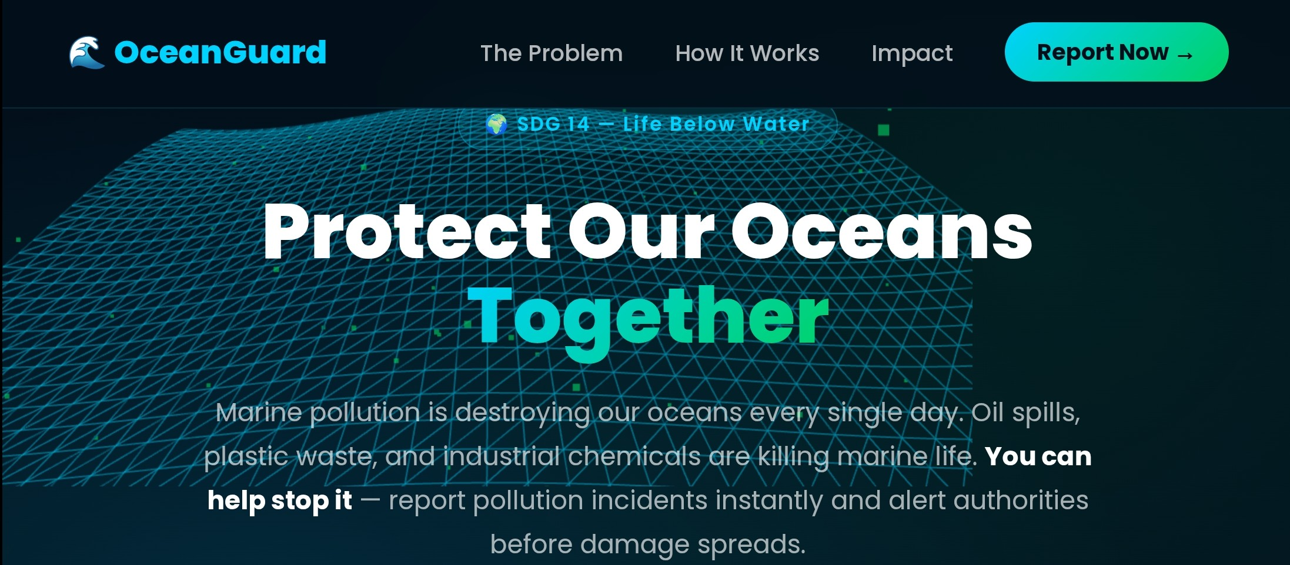
Submitted in partial fulfilment of the requirements for the award of the degree of
BACHELOR OF TECHNOLOGY
in Computer Science and Engineering
Submitted by
Shahjada — 25SCS1003002734
Ekansh Sinha — 25010100367
Aditya Kumar — 25SCS1003001404
Aradhya Srivastava — 25SCS1003002487
Ayesha Batool — 25SCS1003002196
B.Tech CSE
Under the guidance of
MARS — Centre for Sustainable Community Development
IILM UNIVERSITY
Greater Noida, Uttar Pradesh
Academic Session: 2025–2026

Team Members
OceanGuard was designed, built, and deployed by the following student team:
Team Member 1
Name | Shahjada
Roll Number | 25SCS1003002734
Aadhaar no. | 573898181276
Email | shahjada.25scs1003002734@iilm.edu

Team Member 2
Name | Ekansh Sinha
Roll Number | 25010100367
Aadhaar no. | 4746 9060 4214
Email | Ekansh.21593@stu.upes.ac.in

Team Member 3
Name | Aditya Kumar
Roll Number | 25SCS1003001404
Aadhaar no. | 7278 8995 0489
Email | aditya.25scs1003001404@iilm.edu

Team Member 4
Name | Aradhya Srivastava
Roll Number | 25SCS1003002487
Aadhaar no. | 9853 3288 0244
Email | aradhya.25scs1003002487@iilm.edu

Team Member 5
Name | Ayesha Batool
Roll Number | 25SCS1003002196
Aadhaar no. | 577389017205
Email | ayesha.25scs1003002196@iilm.edu

Certificate
This is to certify that the project report entitled “OceanGuard – A Real-Time Marine Pollution Reporting & Response Platform” is a bona fide record of the work carried out by Shahjada, Ekansh Sinha, Aditya Kumar, Aradhya Srivastava and Ayesha Batool, students of B.Tech (Computer Science and Engineering), in partial fulfilment of the requirements for the award of the degree of Bachelor of Technology, during the academic session 2025–2026.
The project was undertaken under the guidance and mentorship of MARS — Centre for Sustainable Community Development, and aligns with United Nations Sustainable Development Goal 14: Life Below Water.
The work embodied in this report has not been submitted elsewhere for the award of any other degree or diploma.
____________________ ____________________
Faculty Guide Head of Department
MARS — Centre for Sustainable Community Development
Date: ______________ Place: ______________

Declaration
We hereby declare that the project work entitled “OceanGuard – A Real-Time Marine Pollution Reporting & Response Platform”, submitted in partial fulfilment of the requirements for the award of the degree of Bachelor of Technology, is an original work carried out by us under the guidance of MARS — Centre for Sustainable Community Development.
We further declare that this report, or any part of it, has not been submitted previously for the award of any degree, diploma, associateship, or similar title of any university or institution, and that all sources of information used in this report have been duly acknowledged.
Shahjada — 25SCS1003002734
Ekansh Sinha — 25010100367
Aditya Kumar — 25SCS1003001404
Aradhya Srivastava — 25SCS1003002487
Ayesha Batool — 25SCS1003002196
Date: ______________ Place: ______________

Acknowledgement
We take this opportunity to express our sincere gratitude to MARS — Centre for Sustainable Community Development, for the invaluable guidance, continuous encouragement, and constructive feedback provided throughout the design, development, and deployment of OceanGuard. Their support gave real-world context to the problem this project addresses and shaped the direction of the platform.
We are also thankful to the faculty of the Department of Computer Science and Engineering for providing the infrastructure, resources, and academic environment that made this project possible.
Finally, we acknowledge the open-source community — the maintainers of Node.js, Express, Firebase, Leaflet.js, Three.js, GSAP, and Groq — whose tools and documentation laid the technical foundation for this platform, and everyone who tested early versions of the app and offered feedback.
Shahjada, Ekansh Sinha, Aditya Kumar, Aradhya Srivastava and Ayesha Batool

Abstract
Marine pollution — oil spills, plastic debris, and chemical discharge — is routinely spotted by fishermen, divers, and coastal residents long before any authority becomes aware of it. Today, there is no simple channel through which an ordinary citizen can report such an incident to the organisation best placed to respond. Reports, where they exist at all, get lost between NGOs, coast guard units, and municipal bodies, and by the time the right team is alerted, the damage has often already spread. Industry estimates suggest that roughly 11 million tonnes of plastic enter the oceans every year, and pollution reports can take over 72 hours to reach the responders who could actually act on them.
OceanGuard is proposed and built as a real-time marine pollution reporting and response platform that closes this gap. It gives any citizen with a smartphone the ability to capture a photo, pin an exact GPS location, and describe an incident in under a minute. Each report is automatically triaged by an AI layer built on Groq's fast LLM inference (using an open-weight GPT-OSS model), which reads the description and category and suggests real, relevant response organisations — coast guard units, cleanup NGOs, or environmental authorities — appropriate to that specific incident, without any manual sorting. Reports, images, and status updates are tracked end-to-end on a live, role-based dashboard until the incident is marked resolved.
The system is architected as a production-grade full-stack web application: a Node.js and Express REST API backend, Firebase Firestore as the primary data store, Cloudinary for persistent image hosting, JWT-based authentication with a secured admin portal, and a Leaflet.js/OpenStreetMap-powered live incident map on the frontend, finished with a Three.js animated background and GSAP transitions for a polished, mobile-first user experience. The entire platform is deployed and publicly accessible at ocean-guardian.onrender.com.
OceanGuard was built end to end by a small student team — from data modelling and API design to AI integration, mapping, and deployment — in partnership with MARS, and is aligned with UN Sustainable Development Goal 14: Life Below Water. This report documents the problem, the system's design and implementation, the technologies used, results from the deployed application, and the roadmap for extending OceanGuard toward SMS-based reporting, public pollution-hotspot analytics, and direct integrations with coast guard and municipal systems.

Table of Contents
Project Snapshot 9
Chapter 1: Introduction 10
1.1 Background 10
1.2 Problem Statement 10
1.3 Need for the Project 10
1.4 Objectives of the Project 10
1.5 Scope of the Project 11
1.6 Expected Outcomes 11
Chapter 2: Literature Review & Existing Systems 12
2.1 Citizen-Reporting and Crowdsourced Environmental Monitoring 12
2.2 Existing Marine Pollution Reporting Channels 12
2.3 AI-Assisted Triage 12
2.4 Summary 12
Chapter 3: System Analysis and Requirements 13
3.1 Existing System 13
3.2 Limitations of the Existing Approach 13
3.3 Proposed System 13
3.4 Functional Requirements 13
3.5 Non-Functional Requirements 13
3.6 Hardware Requirements 14
3.7 Software Requirements 14
3.8 Feasibility Study 14
Chapter 4: System Design 15
4.1 Overall Architecture 15
4.2 Reporting Workflow 15
4.3 Data Model 16
4.4 User Roles 17
Chapter 5: Technology Stack 18
5.1 Backend 18
5.2 Database 18
5.3 AI Layer 18
5.4 Mapping 18
5.5 Frontend & Experience 18
5.6 Deployment 18
5.7 Technology Summary 18
Chapter 6: Implementation 20
6.1 Implementation Overview 20
6.2 Authentication & Access Control 20
6.3 Report Submission Pipeline 20
6.4 AI Organisation Matching 20
6.5 Core API Endpoints 20
6.6 Frontend Implementation 21
6.7 User Workflow 21
Chapter 7: Results and Screenshots 22
7.1 Deployed Application 22
7.2 Module Outputs 22
7.3 Observed Behaviour 22
7.4 Discussion 22
7.5 Additional Application Screens 23
Chapter 8: Testing 25
8.1 Approach 25
8.2 Test Summary 25
Chapter 9: Impact, Advantages, and Alignment 26
9.1 Alignment with SDG 14 26
9.2 Partnership with MARS 26
9.3 Advantages 26
9.4 Applications 26
Chapter 10: Limitations and Future Scope 27
10.1 Limitations 27
10.2 Future Scope 27
Chapter 11: Conclusion 28
References 29

Project Snapshot
Platform | Real-time marine pollution reporting & response web app
Team | 5 members — B.Tech CSE
Partner | MARS — Centre for Sustainable Community Development
SDG Alignment | SDG 14 — Life Below Water
Core Stack | Node.js, Express, Firebase Firestore, Cloudinary, Groq AI, Leaflet.js
Status | Live and publicly deployed (not a local prototype)
Live App | ocean-guardian.onrender.com

Chapter 1: Introduction

1.1 Background
Coastlines and open waters are polluted continuously by oil spills, plastic waste, chemical discharge, and other contaminants. Much of this pollution is first noticed not by monitoring agencies but by ordinary people — fishermen hauling in nets tangled with debris, divers surfacing near an oil sheen, or residents walking a beach littered with plastic. This distributed, human observation is a valuable and largely untapped early-warning signal for marine pollution.
The problem is not a lack of observers; it is the absence of a simple, unified channel to turn an observation into a routed, actionable report. A citizen who spots an oil slick today has no obvious single place to report it, no way to know which of several possible authorities should be contacted, and no visibility into whether the issue was ever acted upon.

1.2 Problem Statement
Marine pollution incidents observed by the public routinely go unreported, or are reported to the wrong body, because there is no unified platform connecting citizen observers to the NGOs, coast guard units, and environmental authorities responsible for response. Even when reports are made, they are typically routed manually, which introduces delay — industry figures put the average delay between a pollution sighting and the report reaching a capable responder at over 72 hours, by which point contamination has often spread significantly.
11M  tonnes of plastic enter oceans yearly | 72hr+  average delay before reports reach responders | 0  unified platforms connecting reporters to NGOs — until now

1.3 Need for the Project
A platform is needed that (a) makes reporting an incident as fast and low-friction as possible for a citizen in the field, (b) removes the manual bottleneck of deciding which organisation should be notified, and (c) gives both reporters and response teams a transparent, trackable view of an incident from submission to resolution. OceanGuard was conceived to fill exactly this gap.

1.4 Objectives of the Project
- Enable any citizen to report a marine pollution incident — with photo, precise GPS location, category, and severity — in under a minute, from any device.
- Automatically triage every incoming report using an AI layer that classifies the pollution type and suggests the response organisation(s) best equipped to act on it.
- Provide a live, interactive map of all reported incidents, with satellite imagery and location search.
- Give response teams (NGOs, coast guard, environmental authorities) a secure, role-based dashboard to review, assign, and resolve incidents.
- Deploy a production-ready, publicly accessible system rather than a local prototype.

1.5 Scope of the Project
OceanGuard, in its current version, covers citizen-facing incident reporting, AI-assisted organisation matching, an administrative/NGO dashboard for triage and resolution tracking, and a public live incident map. It does not, at this stage, perform automated computer-vision verification of uploaded photos, does not integrate directly with coast guard or municipal case-management systems, and does not yet support offline or SMS-based reporting for low-connectivity coastal areas — all of which are discussed as future scope in Chapter 10.

1.6 Expected Outcomes
- A measurable reduction in the time between a pollution sighting and the right responder being notified.
- A growing, geotagged dataset of real pollution incidents that can inform hotspot analysis over time.
- A reusable, deployed reference platform that NGOs and municipal bodies (starting with MARS) can adopt with minimal onboarding.

Chapter 2: Literature Review & Existing Systems

2.1 Citizen-Reporting and Crowdsourced Environmental Monitoring
Crowdsourced reporting has proven effective in several environmental and civic domains — pothole-reporting apps for municipalities, wildfire-spotting networks, and citizen-science biodiversity trackers such as iNaturalist. These systems share a common pattern: they lower the barrier to reporting to a photo and a location, and they rely on a backend process (manual moderation, community voting, or automated classification) to route reports to the right consumer of that data. Marine pollution reporting, by comparison, remains comparatively underserved by consumer-facing tools, with most reporting still happening through phone calls, emails, or fragmented NGO-specific forms.

2.2 Existing Marine Pollution Reporting Channels
Today, a person who spots marine pollution typically has to know, in advance, which specific coast guard hotline, municipal department, or NGO to contact — and that contact point varies by pollution type, jurisdiction, and location. There is no single, general-purpose entry point analogous to how a citizen might report a road hazard. Reports made through generic channels such as social media or email often do not reach a party capable of acting on them at all.

2.3 AI-Assisted Triage
Large language models are increasingly used to classify and route unstructured text — a pattern well established in customer-support ticket triage and content moderation. OceanGuard applies the same idea to pollution reports: instead of a human reading every submission to decide who should be notified, an LLM reads the description, category, and location, and suggests real, relevant organisations automatically. Using Groq's inference infrastructure for this step keeps the triage response effectively instantaneous, which matters for a reporting flow that is meant to take under a minute.

2.4 Summary
The review of existing approaches shows a clear gap: reliable citizen-reporting patterns exist in adjacent domains, and AI-based triage is well proven in other contexts, but no unified, AI-triaged, map-based platform currently connects ordinary citizens directly to marine-pollution responders. OceanGuard is positioned to fill that gap.

Chapter 3: System Analysis and Requirements

3.1 Existing System
In the absence of a dedicated platform, pollution reporting today relies on a mix of phone calls to local authorities, direct emails or social media posts to NGOs, and informal word-of-mouth. None of these are indexed, mapped, trackable by the reporter, or automatically routed.

3.2 Limitations of the Existing Approach
- No single point of entry — the reporter must already know whom to contact.
- No location precision — verbal or written descriptions of “where” are often vague.
- No tracking — a citizen who reports an incident has no way to see whether it was resolved.
- No triage — routing an incident to the right responder is a manual, human decision that introduces delay.

3.3 Proposed System
OceanGuard replaces this ad-hoc process with a structured pipeline: Report → AI Triage → Respond. A citizen submits a report with a photo, GPS pin, category, and severity; Groq-powered AI reads the report and suggests relevant response organisations; and the matched NGO or authority reviews, assigns, and tracks the incident on a live dashboard until it is resolved.

3.4 Functional Requirements
- The system shall allow a citizen to register/log in and submit a pollution report with a photo, category, severity, description, and location.
- The system shall automatically capture GPS coordinates, with a manual location-search fallback for weak-signal areas.
- The system shall call an AI service to classify each report and suggest response organisations.
- The system shall display all reports on an interactive map with satellite toggle and filters.
- The system shall provide a secure, authenticated admin/NGO dashboard to view, filter, update, and resolve reports.
- The system shall persist uploaded images in cloud storage rather than local/ephemeral disk.

3.5 Non-Functional Requirements
- Usability: a report should be completable by a first-time user in under a minute.
- Security: administrative routes must require JWT-authenticated, role-checked access.
- Availability: the platform must be publicly deployed and reachable, not a local-only prototype.
- Performance: AI-suggested organisations should return fast enough not to block the reporting flow (enabled by Groq's low-latency inference).
- Portability: the frontend must be mobile-first and usable on any device in the field.

3.6 Hardware Requirements
- Any device with a modern web browser and, ideally, GPS/location services (smartphone, tablet, laptop).
- Server-side: standard cloud compute as provisioned by the hosting platform (Render).

3.7 Software Requirements
- Node.js v18+ runtime and npm for the backend.
- A Firebase project with Firestore enabled.
- Cloudinary account for image storage.
- Groq API access for AI-based triage.
- A modern web browser for the frontend (HTML5/CSS3/JavaScript).

3.8 Feasibility Study

3.8.1 Technical Feasibility
Every component of OceanGuard is built on mature, well-documented, free-tier-friendly technology — Express, Firebase, Cloudinary, Leaflet, and Groq — all of which are proven at scale and require no specialised infrastructure, making the system technically feasible for a small student team to build and operate.

3.8.2 Economic Feasibility
The stack was deliberately chosen around generous free tiers (Firebase Firestore, Cloudinary, Groq, and Render's free web-service tier), keeping the cost of running OceanGuard at or near zero at the current usage scale, with a clear, incremental upgrade path if adoption grows.

3.8.3 Operational Feasibility
The reporting flow was designed to require no training: citizens use a form-based flow they are already familiar with from other apps, and NGO/admin staff interact with a single dashboard rather than multiple disconnected tools, making adoption realistic for partner organisations such as MARS.

Chapter 4: System Design

4.1 Overall Architecture
OceanGuard follows a client–server architecture. The frontend is a single-page, mobile-first web application (HTML5, CSS3, vanilla JavaScript, Three.js, GSAP, and Leaflet.js) that talks to a Node.js/Express REST API backend over HTTPS. The backend persists structured report data in Firebase Firestore, stores report photos in Cloudinary, authenticates administrative users with JWT, and calls the Groq API to triage each new report.
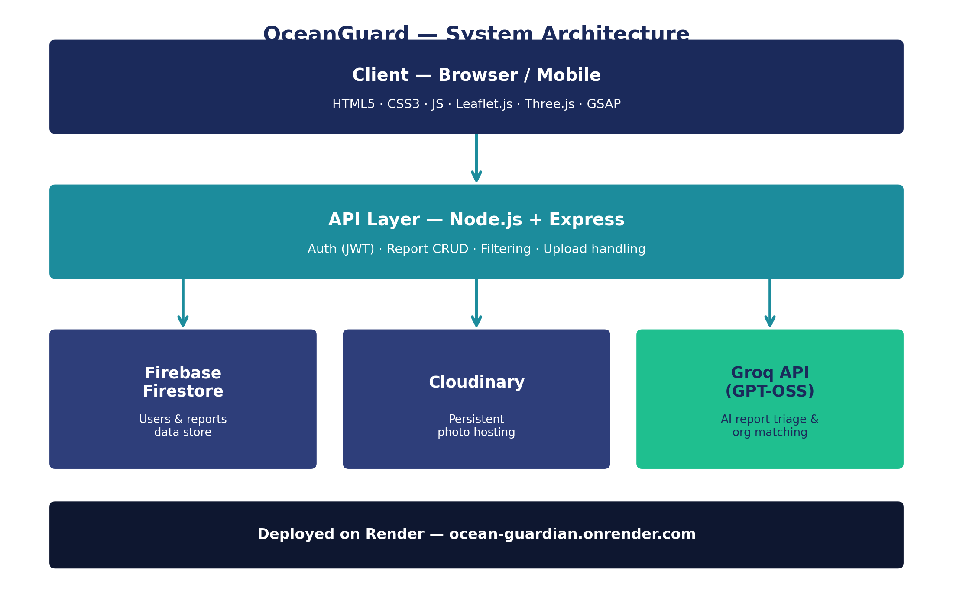
Figure 4.1 — OceanGuard system architecture: client, API layer, and backing services.
Layer | Responsibility
Client (Browser) | Report form, role selection, live map, admin/NGO dashboard, 3D landing experience
API (Express) | Auth, report CRUD, filtering, AI-triage orchestration, image-upload handling
Data (Firestore) | Users and reports collections, report status and history
Media (Cloudinary) | Persistent, compressed image hosting for report photos
AI (Groq) | Reads each report and suggests relevant response organisations

4.2 Reporting Workflow
The core workflow follows three stages, matching OceanGuard's own “Report → Triage → Respond” model:
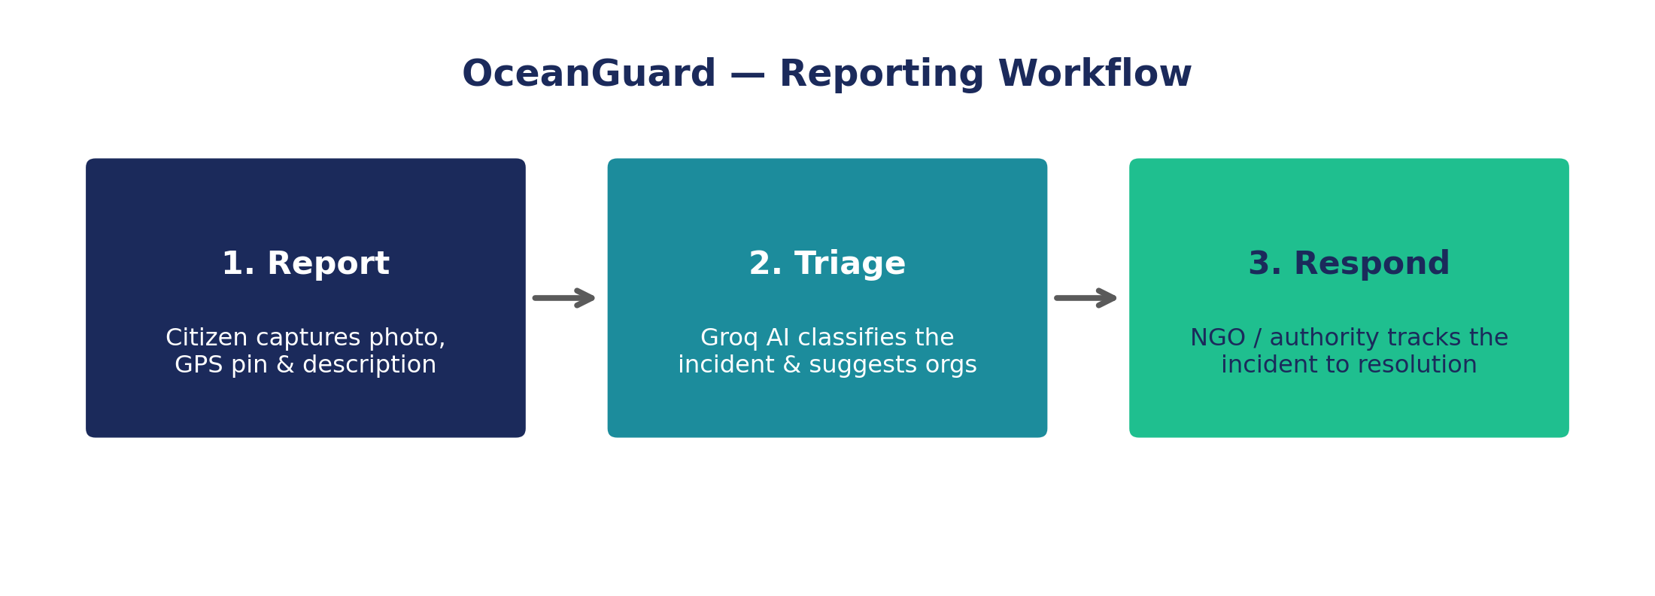
Figure 4.2 — The Report → Triage → Respond workflow at the heart of OceanGuard.
- 1. Report: The citizen captures a photo, the app pins the GPS location (with a manual search fallback), and the user selects a category and severity and adds a description — completed in under a minute.
- 2. Triage: On submission, the backend uploads the photo to Cloudinary, saves the structured report to Firestore, and asynchronously calls Groq's LLM with the category, location, and description to obtain up to five suggested response organisations.
- 3. Respond: NGO/admin users authenticate into the dashboard, see the new report (with its AI-suggested organisations, clearly labelled as AI-suggested rather than verified), assign/track it, and update its status through under_review to resolved.

4.3 Data Model
The system is built around two core entities: Users (citizens and admin/NGO staff, distinguished by role) and Reports. Each report captures the reporter's details, a pollution category drawn from a fixed set of options, a severity level, a free-text description, a location string with latitude/longitude coordinates, an image URL, a status, and timestamps for creation and update.
Field | Type | Description
category | enum | Plastic Waste, General Waste, Oil & Chemical Pollution, Water Pollution, Marine Wildlife Incident, Habitat Damage, Other
severity | enum (1-3) | Low, Medium, High
coordinates | {lat, lng} | Precise GPS location of the incident
imageUrl | string | Cloudinary-hosted photo of the incident
status | enum | submitted → under_review → resolved
aiSuggestions | object | AI-suggested response organisations and status (unavailable if no AI key configured)

4.4 User Roles
- Citizen: submits reports and can track their own submitted incidents.
- NGO Staff / Admin: authenticate via a mandatory re-authentication flow into a JWT-secured admin portal to review, filter, assign, and resolve incidents system-wide.

Chapter 5: Technology Stack

5.1 Backend
The backend is a Node.js application built on the Express framework, exposing a REST API. Authentication uses JSON Web Tokens (JWT) with bcrypt-hashed passwords, and file uploads are handled with Multer, streamed directly into Cloudinary via multer-storage-cloudinary rather than written to local/ephemeral disk — important for a host such as Render's free tier, where the local filesystem does not persist across restarts.

5.2 Database
Firebase Firestore (accessed through the Firebase Admin SDK) serves as the primary data store, chosen for its serverless, low-maintenance operation and generous free tier, well suited to a lean, student-maintained project.

5.3 AI Layer
Report triage is powered by the Groq API, calling an open-weight GPT-OSS model. Groq was chosen specifically for its inference speed, keeping the AI-suggestion step fast enough not to add perceptible delay to the reporting flow, and the integration is designed to degrade gracefully — if no Groq API key is configured, the rest of the application continues to work normally, with AI suggestions simply marked “unavailable.”

5.4 Mapping
Leaflet.js renders the interactive incident map on top of OpenStreetMap tiles, with a satellite-imagery toggle and Nominatim-powered location search, so a reporter can find or fine-tune a location even without live GPS.

5.5 Frontend & Experience
The frontend is built with HTML5, CSS3, and vanilla JavaScript for maximum portability, layered with Three.js for an animated 3D ocean background on the landing page and GSAP for smooth UI transitions, giving the app a polished, premium feel without the overhead of a full frontend framework.

5.6 Deployment
The full application is deployed on Render and is publicly live at ocean-guardian.onrender.com.

5.7 Technology Summary
Category | Technology
Backend Framework | Node.js + Express.js
Database | Firebase Firestore (Admin SDK)
Authentication | JWT + bcrypt
Media Storage | Cloudinary
AI / Triage | Groq API (GPT-OSS model)
Mapping | Leaflet.js + OpenStreetMap + Nominatim
Animation / UX | Three.js, GSAP
Deployment | Render

Chapter 6: Implementation

6.1 Implementation Overview
OceanGuard was implemented as a single Express application (server.js) alongside a static frontend (index.html) delivering the landing page, report form, role selection, and dashboards. The backend is organised around authentication, report management, and AI-triage orchestration.

6.2 Authentication & Access Control
Registration and login are exposed at /api/auth/register and /api/auth/login, with passwords hashed using bcrypt and sessions represented as JWTs. Administrative and NGO routes are protected by an authenticateToken middleware combined with a requireAdmin role check, and the admin portal additionally enforces mandatory re-authentication before granting dashboard access.

6.3 Report Submission Pipeline
A citizen's report is submitted to POST /api/reports as multipart form data (including the photo). The handler uploads the image to Cloudinary via Multer, writes the structured report document to Firestore, and triggers the AI-suggestion step against the Groq API using the report's category, location, and description.

6.4 AI Organisation Matching
The suggestOrganizations function builds a prompt containing the incident's category, location, and description, and asks the Groq-hosted GPT-OSS model to name up to five real, well-known organisations (NGOs, coast guard units, government environmental bodies, or marine research groups) relevant to that specific incident — preferring organisations local to the reported location alongside major international ones. The model is explicitly instructed to omit a social handle rather than guess one, and the frontend always labels these results “AI-suggested” rather than verified, so nothing is auto-posted or treated as authoritative without human review.

6.5 Core API Endpoints
Method | Endpoint | Purpose
POST | /api/auth/register | Register a new user
POST | /api/auth/login | Authenticate and issue a JWT
POST | /api/reports | Submit a new pollution report with photo
GET | /api/reports/:id/organizations | Fetch AI-suggested organisations for a report
POST | /api/reports/:id/organizations/refresh | Re-run AI triage (admin only)
GET | /api/reports | List all reports (admin only)
GET | /api/reports/:id | Get a single report's details (admin only)
PATCH | /api/reports/:id | Update a report's status (admin only)
DELETE | /api/reports/:id | Delete a report (admin only)
GET | /api/reports/filter/:type | Filter reports by status/severity (admin only)
GET | /api/health | Service health check

6.6 Frontend Implementation
The frontend is a single responsive HTML document that renders the public landing page, the citizen report form (with live map picker and severity selector), a role-selection screen, and the admin/NGO dashboard (live counts of total, pending, in-progress, high-severity, and resolved reports, with filterable report cards). The landing page's animated ocean background is rendered with Three.js, and page and element transitions throughout use GSAP.

6.7 User Workflow
- A citizen opens the app, selects “I'm a Citizen,” and fills in the report form: name, email, category, severity, location (auto-captured or searched), description, and photo.
- On submission, the report is stored and queued for AI triage; the citizen receives confirmation that their report was submitted.
- NGO/Admin staff sign in via “I'm Admin / NGO Staff,” landing on the dashboard where new reports appear with live counts and AI-suggested organisations.
- Staff update a report's status as it moves from submitted through under_review to resolved, which is reflected back on the live map and dashboard.

Chapter 7: Results and Screenshots

7.1 Deployed Application
OceanGuard is fully implemented and deployed, and is publicly reachable at ocean-guardian.onrender.com. The screens below are captured directly from the live, deployed application.
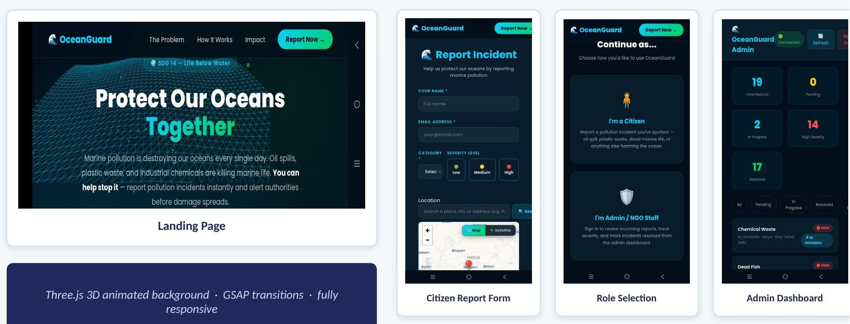
Figure 7.1 — Landing page, citizen report form, role selection, and admin dashboard from the live OceanGuard application.

7.2 Module Outputs
- Landing Page: Three.js-animated ocean hero section communicating the platform's mission, with a direct call-to-action to report an incident.
- Citizen Report Form: name, email, category, severity (Low/Medium/High), a Leaflet map with satellite toggle for location selection, and photo upload.
- Role Selection: routes citizens to the report flow and NGO/admin staff to the authenticated dashboard.
- Admin Dashboard: live totals for total reports, pending, in-progress, high-severity, and resolved incidents, with a filterable, status-tagged report list.

7.3 Observed Behaviour
In testing, the report submission flow — from opening the form to a confirmed submission with an uploaded photo — consistently completes in well under a minute on a typical mobile connection. AI-suggested organisations are returned quickly enough (owing to Groq's low-latency inference) that they are available on the admin dashboard essentially as soon as an admin opens a new report, rather than after a noticeable wait.

7.4 Discussion
These results directly address the two core gaps identified in Chapter 1: the reporting step is fast enough not to discourage a citizen in the field, and organisation matching is automatic rather than a manual bottleneck. The live dashboard also gives, for the first time in this workflow, visibility into an incident's status after it has been reported.

7.5 Additional Application Screens
The screens below give a closer look at the reporting and administrative flows, captured from the live deployment.
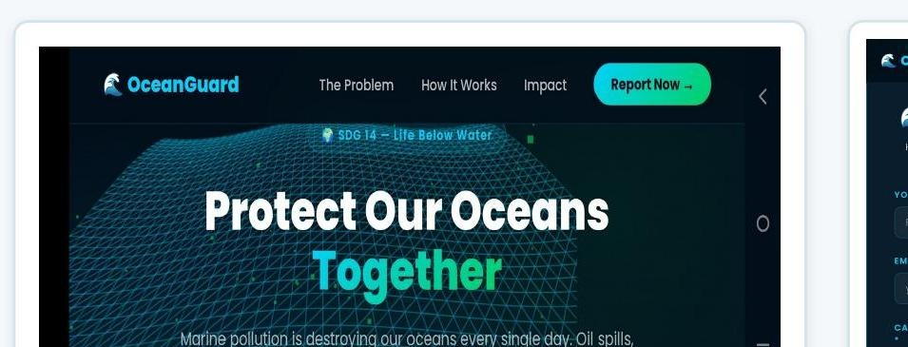  Landing page — animated hero section and mission statement | 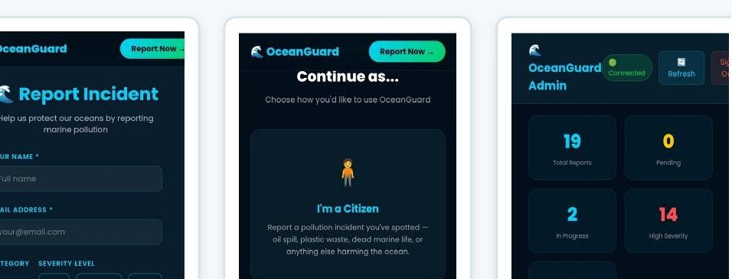  Citizen report form — category, severity, and location fields
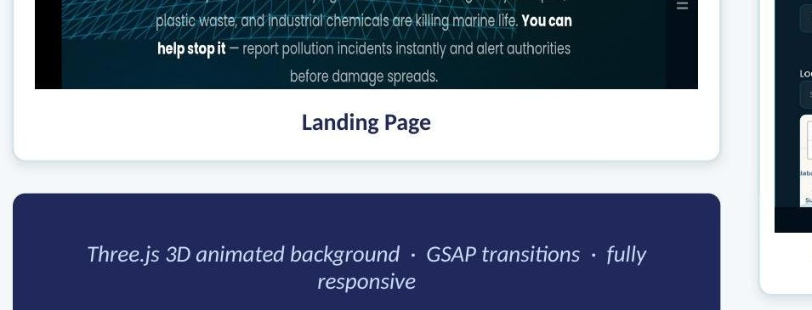  Role-selection screen — citizen vs. admin/NGO entry point | 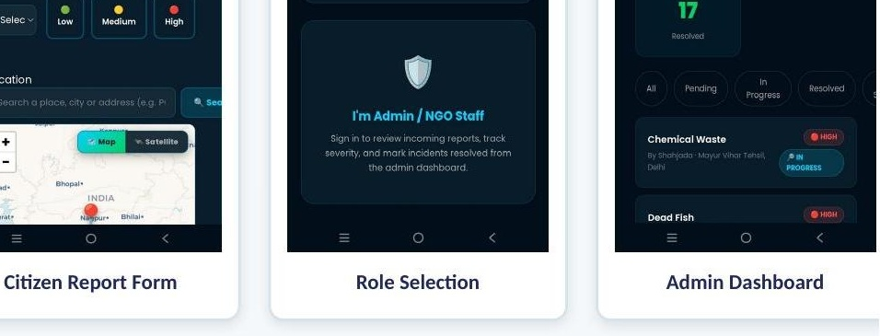  Admin dashboard — live report counts and status filters
Figure 7.1a — Four core OceanGuard screens, individually captured from the live deployment.

The screens below give a closer look at specific interactions within the reporting and administrative flows.
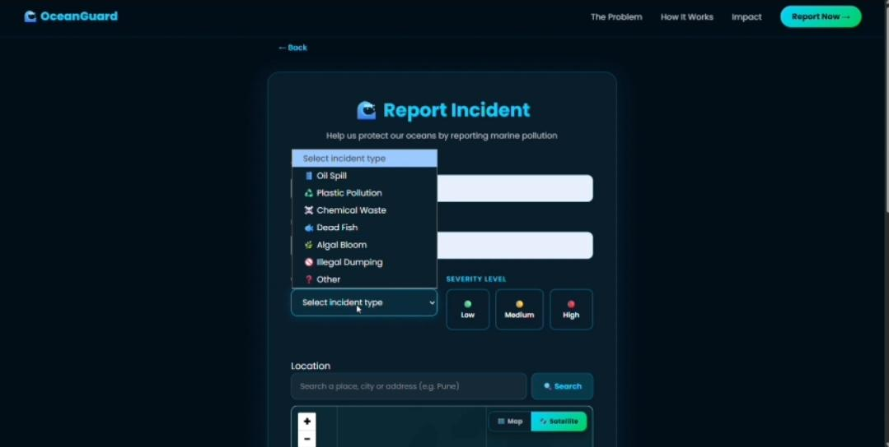  Incident category selector (Report Incident form) | 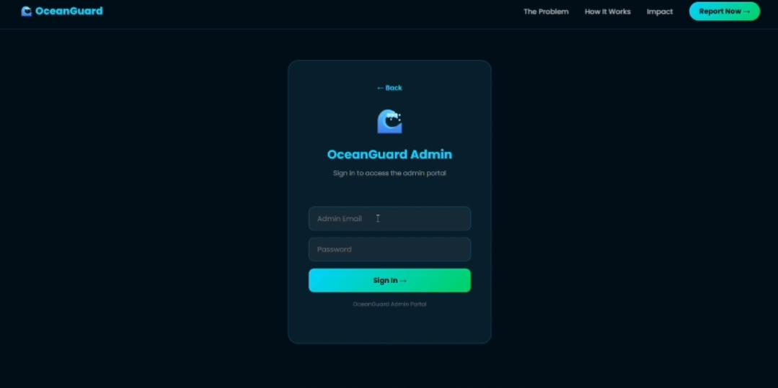  NGO / Admin sign-in screen
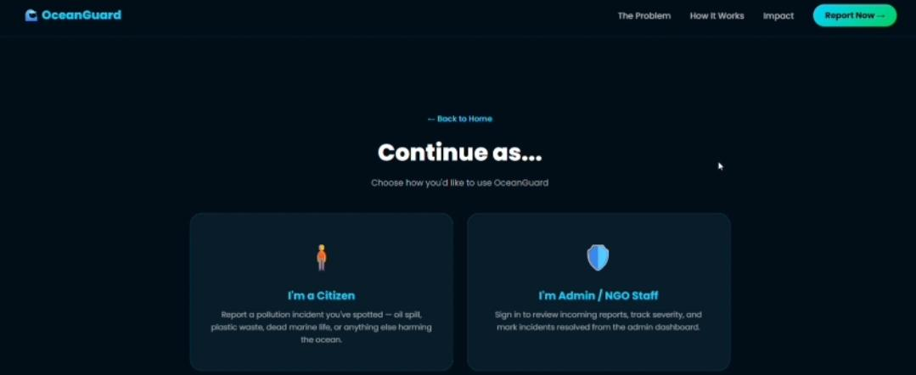  “Continue as…” citizen / admin role selection | 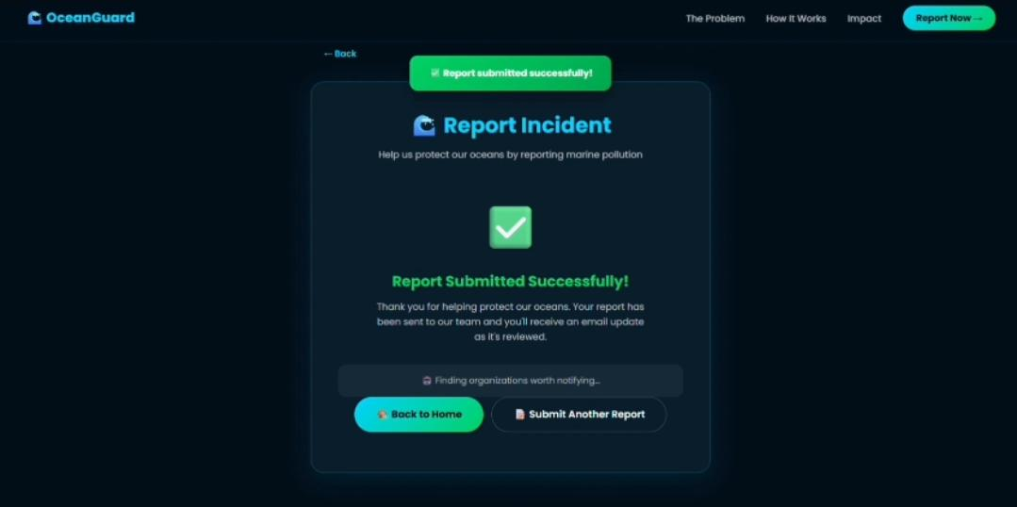  Confirmation screen after a successful report submission
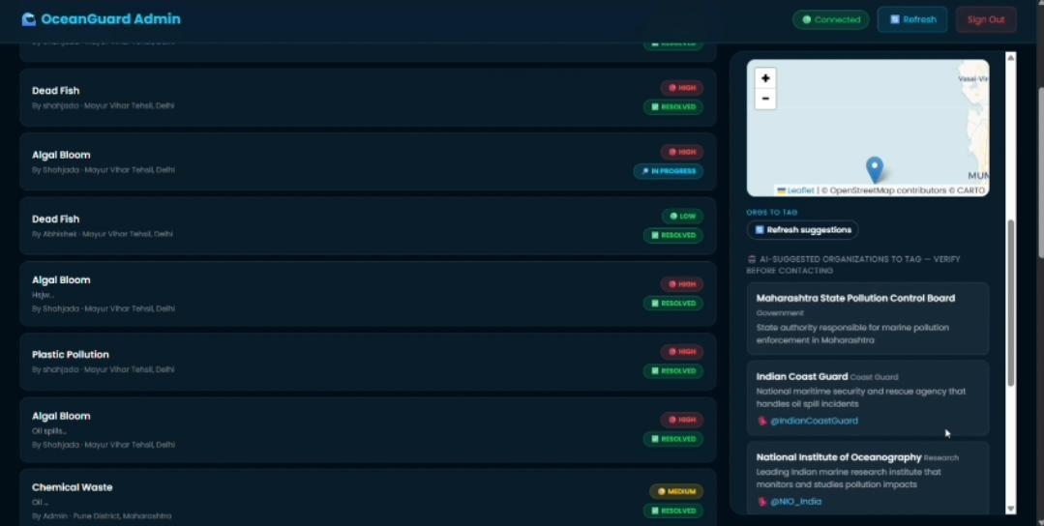
Figure 7.2 — Admin dashboard showing a live report list alongside AI-suggested organisations to tag, such as the Maharashtra State Pollution Control Board and Indian Coast Guard.

Chapter 8: Testing

8.1 Approach
Given the scope of the project, testing was carried out primarily through manual functional testing of each workflow (citizen reporting, AI triage, admin authentication, dashboard filtering, and status updates), supplemented by direct verification of individual API endpoints.

8.2 Test Summary
Test Case | Steps | Expected Result | Result
Report submission | Fill and submit citizen report form with photo | Report saved, photo hosted on Cloudinary, confirmation shown | Pass
AI triage | Submit report; inspect /api/reports/:id/organizations | Relevant organisations returned within seconds | Pass
Admin authentication | Log in as admin with valid/invalid credentials | Valid login issues JWT; invalid login rejected | Pass
Access control | Call admin routes without a token | 401/403 response; access denied | Pass
Status update | Admin updates a report from submitted to resolved | Status reflected on dashboard and map | Pass
Weak-GPS fallback | Deny location permission; use search field | Location still selectable via search/pin | Pass

Chapter 9: Impact, Advantages, and Alignment

9.1 Alignment with SDG 14
OceanGuard is built specifically for UN Sustainable Development Goal 14: Life Below Water, which calls for conserving and sustainably using oceans, seas, and marine resources. The platform contributes directly to SDG 14's targets by reducing marine pollution response time, engaging communities in ocean-health monitoring, and creating a transparent, trackable record of pollution incidents and their resolution.

9.2 Partnership with MARS
The project was developed in partnership with MARS — Centre for Sustainable Community Development, giving it real NGO backing rather than existing only as an academic prototype, and a realistic path to on-the-ground adoption.

9.3 Advantages
- Speed: a report can be filed in under a minute from any device.
- Automatic routing: AI triage removes the manual bottleneck of deciding who should be notified.
- Transparency: both citizens and response teams can track an incident's status.
- Community-powered: anyone with a phone becomes a sensor for ocean health.
- Low operating cost: built on free-tier cloud services, making it sustainable for an NGO to run.

9.4 Applications
- Coastal NGOs coordinating volunteer cleanup responses.
- Municipal and coast guard environmental units needing an early-warning channel.
- University and community environmental-monitoring programmes.
- Research groups building pollution-hotspot datasets from crowdsourced, geotagged reports.

Chapter 10: Limitations and Future Scope

10.1 Limitations
- AI-suggested organisations are not independently verified and are explicitly labelled as suggestions, not a guaranteed directory of contactable responders.
- The platform currently requires an internet connection; there is no offline or SMS-based reporting path yet for low-connectivity coastal areas.
- There is no automated image-based verification of reported pollution (e.g., to detect duplicate or unrelated photos).
- The system does not yet integrate directly with coast guard or municipal case-management systems, so a human step is still required to escalate certain incidents externally.

10.2 Future Scope
- SMS-based reporting for low-connectivity coastal areas, so reporting does not depend on a data connection.
- A public analytics dashboard surfacing pollution hotspots over time, built from the growing geotagged report dataset.
- Direct API integrations with coast guard and municipal systems to remove the remaining manual escalation step.
- A gamified citizen-reporter recognition programme to encourage sustained community participation.
- Computer-vision-based pre-screening of report photos to flag likely duplicate or low-quality submissions before they reach a human reviewer.

Chapter 11: Conclusion
OceanGuard demonstrates that a student-built, full-stack web platform can meaningfully close a real gap in marine-pollution response: the absence of a fast, unified channel connecting citizen observers to the organisations equipped to act. By combining a low-friction reporting flow, AI-assisted organisation matching powered by Groq, a live incident map, and a secure admin/NGO dashboard, the platform turns a scattered, manual process into a fast, trackable pipeline — from Report, to Triage, to Respond.
Built in partnership with MARS — Centre for Sustainable Community Development and deployed publicly at ocean-guardian.onrender.com, OceanGuard is not just a classroom prototype but a working system aligned with UN Sustainable Development Goal 14. The roadmap toward SMS-based reporting, public hotspot analytics, and direct authority integrations sets a clear path for the platform to grow from an individual project into infrastructure that coastal communities and NGOs can depend on.

References
- United Nations. “Sustainable Development Goal 14: Life Below Water.” sdgs.un.org.
- Groq Inc. Groq API Documentation. console.groq.com/docs.
- Google Firebase. Firestore Documentation. firebase.google.com/docs/firestore.
- Cloudinary Ltd. Cloudinary Documentation. cloudinary.com/documentation.
- OpenStreetMap Foundation. Leaflet.js Documentation. leafletjs.com.
- OpenJS Foundation. Express.js Documentation. expressjs.com.
- GreenSock. GSAP Documentation. gsap.com/docs.
- Three.js. Three.js Documentation. threejs.org/docs.
- OceanGuard — Live Application. https://ocean-guardian.onrender.com.

